SLC TASK -1
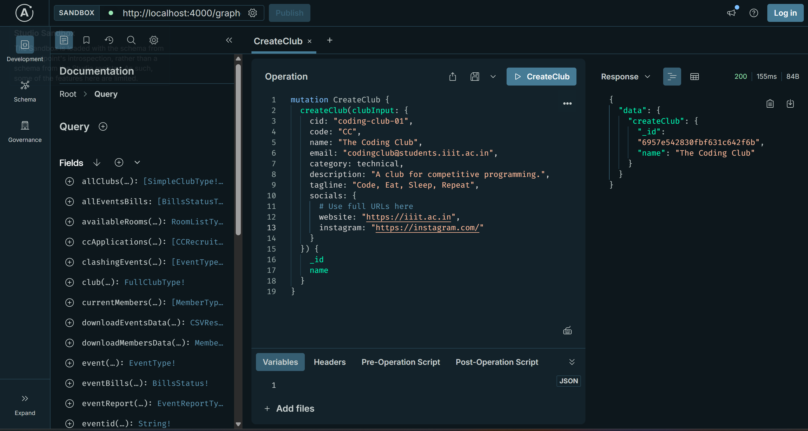
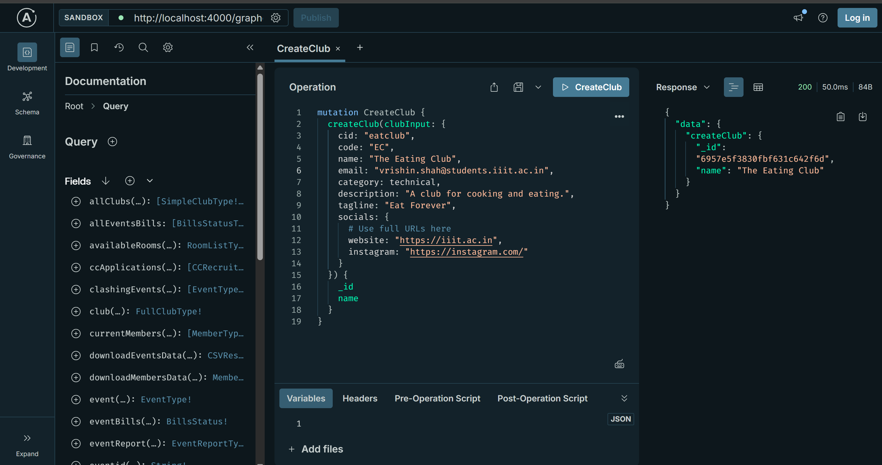
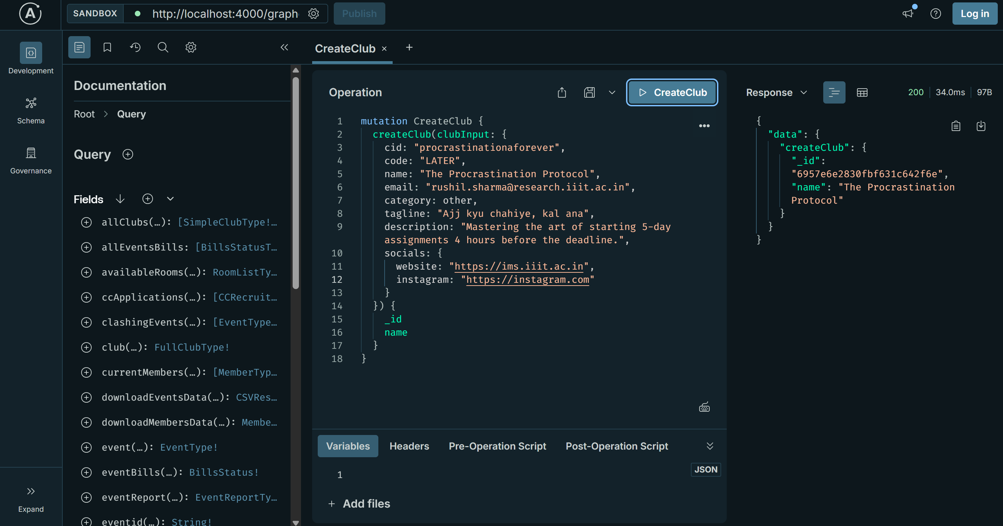

Created a new club with the above field. The Query Structure that has to be sent to the gateway was found via the pydantic model in subgraphs/club/models.py

Adding Member To Club
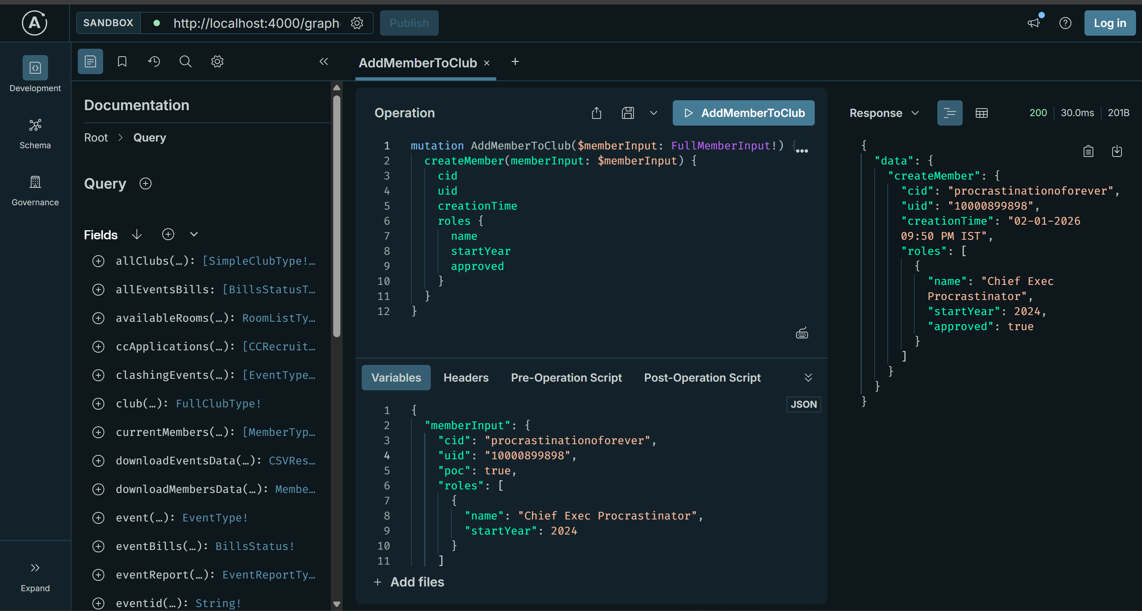
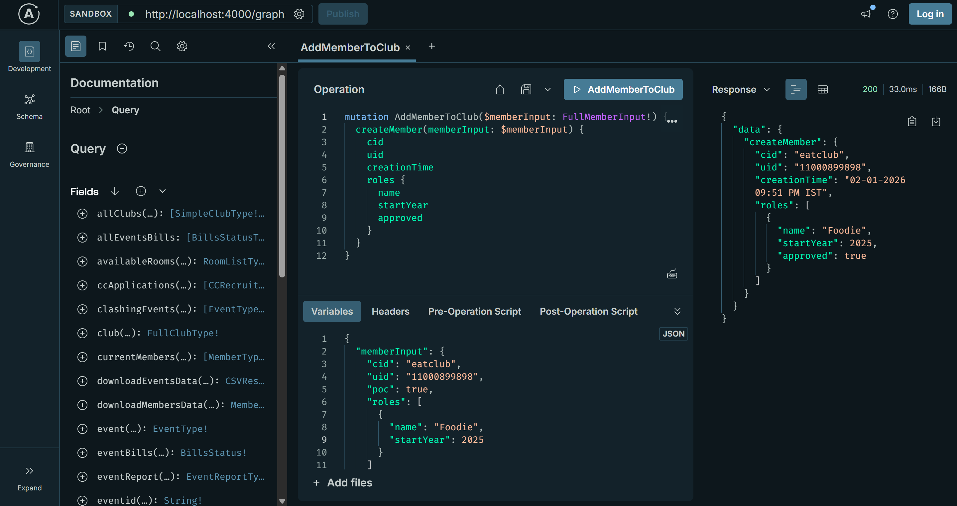
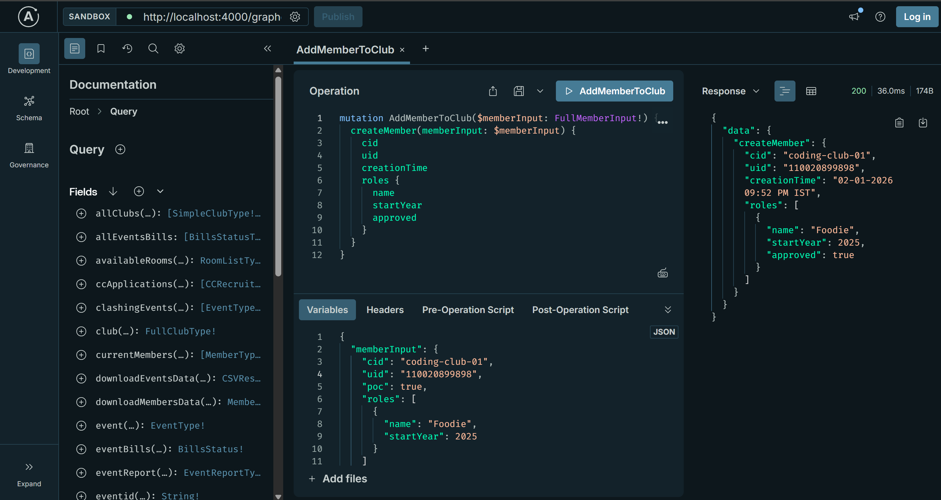
Added member to each club.
Members were added by seeing the models (pydantic) and commenting out the authentication from club member for adding a member to club in fnc “async def createMember(memberInput: FullMemberInput, info: Info) -> MemberType:”

Adding events to each club
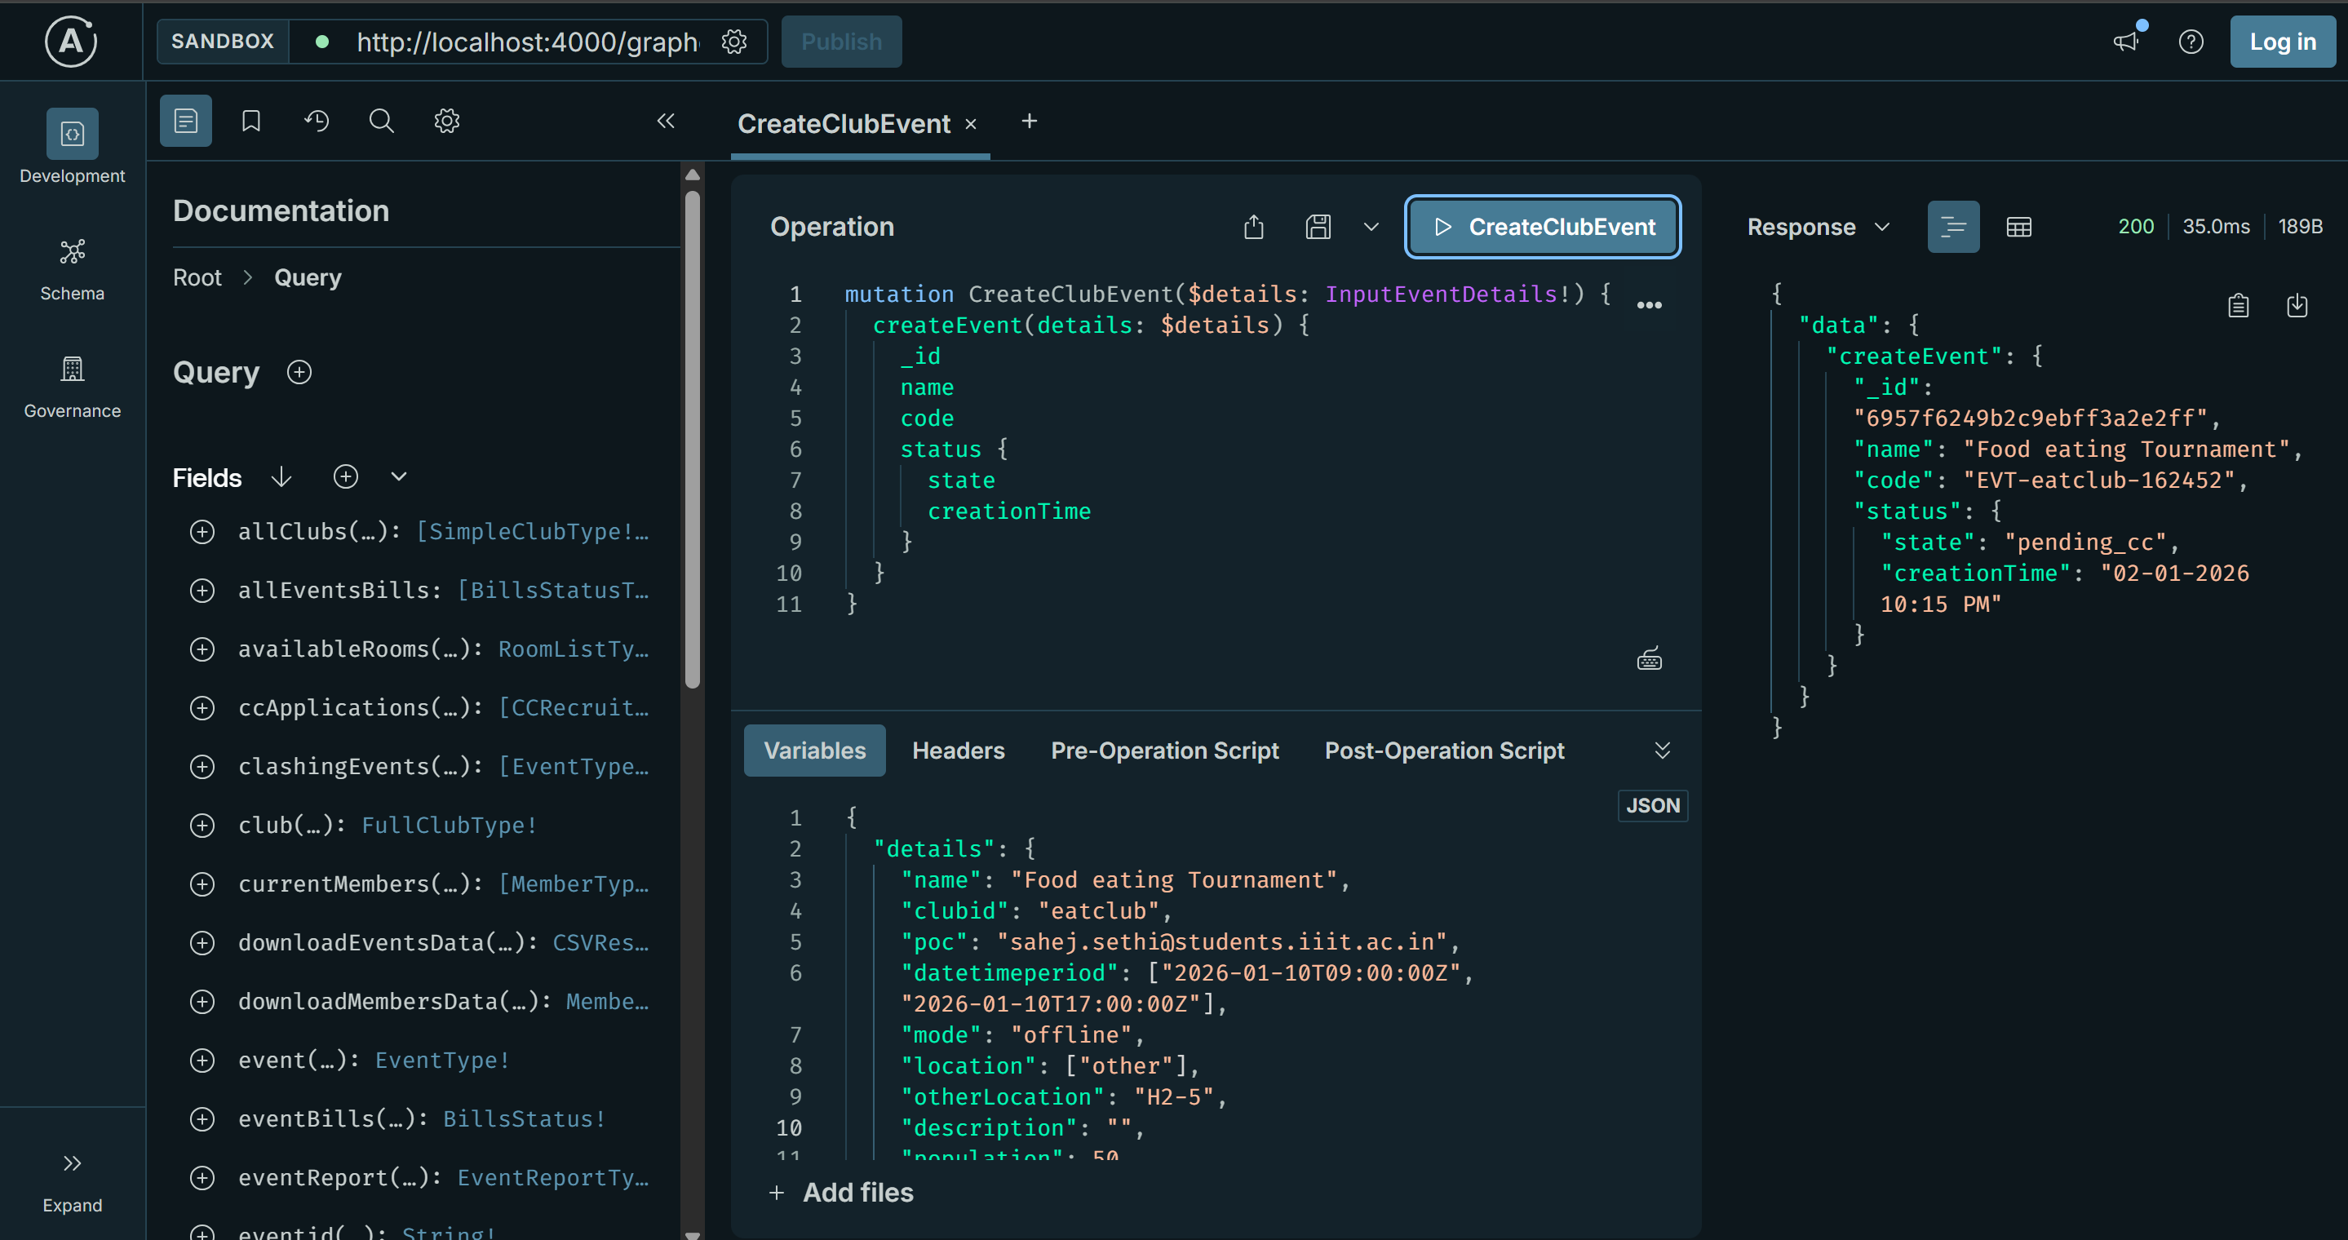
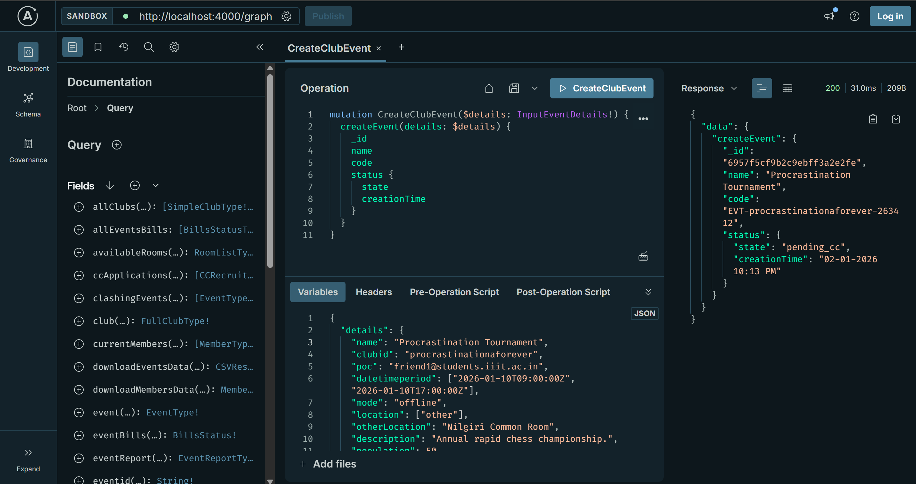
Members are added to each club. Commentted down the auth functions of the user sending the requests to add the member.

